Case Study
Predictive Analytics to Optimize Patient Care in Mexico City
Technologies Used: Machine Learning, Predictive Analytics, Scikit-learn, XGBoost, Python, Google Cloud Platform (GCP), Vertex AI, BigQuery, React, TailwindCSS, Data Pipelines.

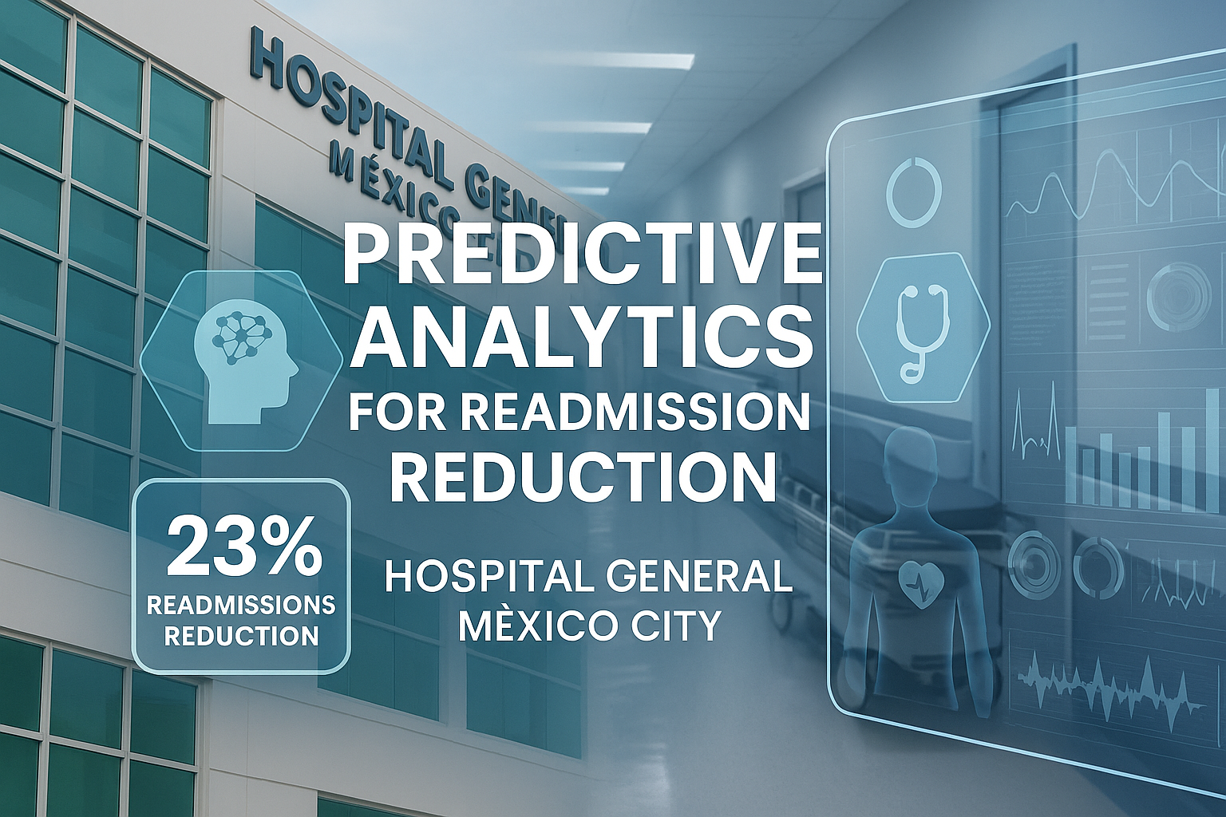
Executive Summary
Robles.AI partnered with a network of hospitals in Mexico City to implement an artificial intelligence system focused on predictive analysis of patient readmission risk. This system enabled the identification of critical factors and proactive actions to reduce readmissions. In just six months, it achieved 87% accuracy in predicting readmissions and a 23% reduction in actual readmissions. This advancement positioned the participating hospitals as leaders in AI-driven medical innovation in Mexico.
Key Components and System Architecture
- Data Source: Electronic health records, discharge summaries, diagnoses, treatments, age, comorbidities, and treatment adherence levels.

- AI Engine: Machine learning models developed with Scikit-learn and XGBoost, trained on 90,000 anonymized records.

- Processing Pipeline: Data cleaning, normalization, and variable encoding implemented in Python using Pandas and Scikit-learn.

- Cloud Platform: Infrastructure deployed on Google Cloud Platform (GCP) using Vertex AI and BigQuery.

- Clinical Dashboard: Web interface built with React and Tailwind displaying predictions, patient-specific explanations (SHAP values), and weekly reports.

- HL7/FHIR Integration: Bidirectional communication with the hospital information system (HIS).

Etapas del Proyecto
- Data Exploration and Preparation
  - Data was extracted and anonymized from the last 3 years of hospital discharges.
  - Three public hospitals and two private hospitals participated, under IMSS and the Ministry of Health ethical oversights.
- Model Validation
  - The dataset was split into training and testing sets (80/20).
  - The final model achieved 87% accuracy (AUC = 0.91) and 82% recall on actual readmissions.
  - The model was validated during a 4-week pilot at a hospital in southern Mexico City.
- Deployment and Integration
  - The system was integrated into the patient discharge workflow.
  - Alerts were generated for patients with a risk score over 70%.
  - 52 healthcare professionals were trained to interpret the results.
- Community Adoption and Clinical Review
  - Personalized post-discharge follow-up strategies were implemented.
  - A medical committee conducted monthly reviews of the most relevant cases.

Case Study
Predictive Analytics to Optimize Patient Care in Mexico City
"Thanks to predictive analytics, we can anticipate readmission risk and provide timely follow-up to our vulnerable patients. This not only improves clinical outcomes but also strengthens families’ trust. The system is now essential to our medical decision-making."
— Dr. Fernanda Cruz, Medical Director
General Hospital of Mexico City
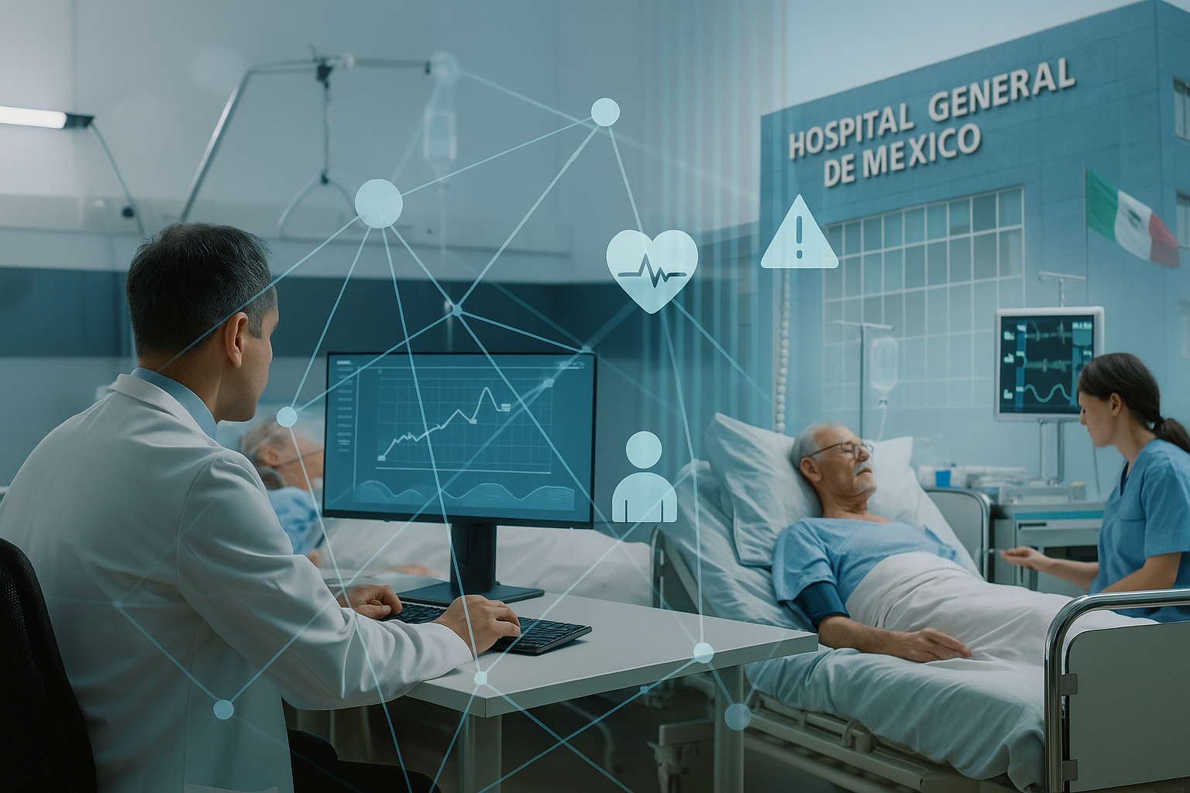

Results Achieved
- 87% accuracy in predicting hospital readmission risk
- 23% reduction in readmissions over the following six months
- 94% clinical acceptance, according to an internal survey of attending physicians
- Resource reallocation: fewer hospital beds occupied by recurrent cases
Impact on the Healthcare System
The system not only improved clinical indicators but also strengthened operational planning and enabled doctors to make better-informed decisions. Its preventive approach promoted patient well-being by avoiding unnecessary hospitalizations.
Doctors appreciated the model’s ability to uncover hidden factors and suggest early interventions. The system’s interoperability with existing platforms facilitated its adoption with minimal technological friction.
Conclusion
This case study demonstrates how properly integrated and validated artificial intelligence can significantly transform patient care. Robles.AI will continue expanding these solutions across Latin America to help build more preventive, efficient, and patient-centered healthcare systems.

